**Secured Multi Owner Data Sharing For Dynamic Groups In Cloud**

A summer internship report submitted for pre final year of

**Bachelor of Technology**

In

**Computer Science and Engineering**

By

K.Mani (N120642)

*Under the Supervision of*

Mr. Venkat

Mr. Amit patel



**Department of Computer Science and Engineering**

**Rajiv Gandhi University of Knowledge Technologies – Nuzvid**

**Nuzvid, Krishna – 521202**

July, 2017

**--------------------------------------------------------------------------------------------------------------------------------------**

**Rajiv Gandhi University of Knowledge Technologies**

**(A.P. Government Act 18 of 2008)**

**RGUKT-NUZVID, Krishna Dist - 521202**

Tele Fax : 08656 – 235557/235150

## CERTIFICATE OF COMPLETION

This is to certify that the work entitled, “**Secured Multi Owner Data Sharing For Dynamic Groups In Cloud”** is the bonafied work of ***K.Mani (ID No: N120642)*** carried out under my guidance and supervision for pre final year project of **Bachelor of Technology** in the department of Computer Science and Engineering under RGUKT IIIT Nuzvid. This work is done during the academic session June2017 – July 2017, under our guidance.

­­

Director

EdgeTech

University Guide

**Mr. Amit Patel**

Faculty,Department of CSE,

RGUKT IIIT Nuzvid,

Nuzvid.

**--------------------------------------------------------------------------------------------------------------------------------------**

**Rajiv Gandhi University of Knowledge Technologies**

**(A.P. Government Act 18 of 2008)**

**RGUKT-NUZVID, Krishna Dist - 521202**

Tele Fax : 08656 – 235557/235150

## CERTIFICATE OF EXAMINATION

This is to certify that the work entitled, “**Multi Owner Data Sharing For Dynamic Groups In Cloud”** is the bonafied work of ***K.Mani (ID No: N120642)*** here by accord our approval of it as a study carried out and presented in a manner required for its acceptance in pre final year of **Bachelor of Technology** for which it has been submitted. This approval does not necessarily endorse or accept every statement made, opinion expressed or conclusion drawn, as a recorded in this thesis. It only signifies the acceptance of this thesis for the purpose for which it has been submitted.

­­

---------------------------------------- ----------------------------------

**Project Supervisor Examiner**

**Mr.Amit Patel** Faculty,Department of CSE,

Lecturer Dept. of CSE, RGUKT IIIT, Nuzvid.

RGUKT IIIT, Nuzvid .

**--------------------------------------------------------------------------------------------------------------------------------------**

**R Rajiv Gandhi University of Knowledge Technologies**

**(A.P. Government Act 18 of 2008)**

**RGUKT-NUZVID, Krishna Dist - 521202**

Tele Fax : 08656 – 235557/235150

## DECLARATION

I am, ***K.Mani (ID No:N120642)*** hereby declare that the project report entitle “**Multi Owner Data Sharing For Dynamic Groups In Cloud”** done by us under the guidance of **Mr. Venkat** is submitted for pre final year of **Bachelor of Technology** in **Computer Science and Engineering** the academic session June2017 – July 2017 at Vizag.

We also declare that this project is a result of our own effort and has not been copied or imitated from any source. Citations from any websites are mentioned in the references.

The results embodied in this project report have not been submitted to any other university or institute for the award of any degree or diploma.

­­

**Date : 31-07-2017 K.Mani(N120642)**

**Place : Vizag**

**ACKNOWLEDGEMENT**

I wish to express my deep sense of gratitude and sincere thanks to our Head of the Department **Mr**.**R. UpendarRao** for his encouragement, timely help and advice offered to me.

The thesis would not have been possible without help and support of my guides. The good advice and support of **Mr.Venkat, Supervisor Of EdgeTech** has been valuable on academic level, for which I’m extremely grateful. His attention and moral support and timely suggestions were very useful in preparation of my thesis. I’m very thankful to him for his support and putting me on a right track of this work.

I’m also very thankful to the team of  **EdgeTech** for providing me friendly environment for my work, guiding and providing all help in my needs during project. They have a great contribution in performing my practical work during my project. I would also like thank my friends, colleagues and all other employee of Harmony info-tech for their support in my work

**K.Mani (N120642)**

**ABSTRACT**

With the character of low maintenance, cloud computing provides an economical and efficient solution for sharing group resource among cloud users. Unfortunately, sharing data in a multi- owner manner while preserving data and identity privacy from an untrusted cloud is still a challenging issue, due to the frequent change of the membership. In this paper, we propose a secure multi owner data sharing scheme, named Mona, for dynamic groups in the cloud. By leveraging group signature and dynamic broadcasting, any cloud user can anonymously share data with others. Meanwhile, the storage overhead and encryption computation cost of our scheme are independent with the number of revoked users. In addition, we analyze the security of our scheme with rigorous proofs, and demonstrate the efficiency of our scheme in experiments.

**CONTENTS**

1. **Introduction** ……………………………………………... 01
2. **System Analysis** ……………………………………………... 02

2.1 Existing System…………………………………………… 02

2.2 Proposed System…………………………………………… 03

1. **Feasibility Study**….…………………………………………….. 04

3.1 Economic Feasibility……………………………………….. 05

3.2 Technical Feasibility………………………………………. 05

3.3 Social Feasibility…………………………………………… 05

1. **Literature Survey**……. ……………………………………... 06
   1. Related Study……………… ……………………............... 07
2. **Technology Description**………………………….……………… 08
   1. Language Supported By .Net………………………………. 09
   2. Features Of Sql-Server……………………………………….. 10
3. **System Design**…………………….……………………………… 11-13
4. **Implementation**………………………………………………… 14

7.1 Cloud Module…………………………………………………. 14

7.2 Group Manager Module………………………………………… 15

7.3 Group Member Module………………………………………… 15

7.4 Group Signature Module………………………………………… 16

7.2User Revocation ………………………………………………… 16

**8. Output Screenshots**………………………………………………… 17-21

**9. Conclusion**…………………………………………………………… 23

**10. Future Enhancement**……………………………………………… 24

**11. References**…………………………………………………………… 25

**LIST OF FIGURES**

5.1 . NET Framework 09

6.1 Data Flow Diagram 11

6.3 UseCase Diagram 12

6.4 Sequence Diagram 13

7.1 System Architecture 16

8.1 Welcome Page 17

8.2 Admin Home Page 17

8.3 Member List 18

8.4 File List 18

8.5 Deactivation Of User By Group Member 19

8.6 User Registration 19

8.7 User Login 19

8.8 Deactivation Of User 20

8.9 File Upload 21

8.10 File Download 21

8.11 File Deletion

**CHAPTER 1**

**INTRODUCTION**

Cloud computing is recognized as an alternative to traditional information technology due to its intrinsic resource-sharing and low-maintenance characteristics. One of the most fundamental services offered by cloud providers is data storage. To preserve data privacy, a basic solution is to encrypt data files, and then upload the encrypted data into the cloud. Unfortunately, designing an efficient and secure data sharing scheme for groups in the cloud is not an easy task due to the following challenging issues:

➢ Identity privacy

➢ Single Owner

➢ Dynamic nature of Groups

In several security schemes such as Plutus[1], Sirius[2], etc proposed for data sharing on untrusted servers, the data owners store the encrypted data files in untrusted storage and distribute the corresponding decryption keys only to authorized users. Thus, unauthorized users as well as storage servers cannot learn the content of the data files because they have no knowledge of the decryption keys. However, the complexities of user participation and revocation in these schemes are linearly increasing with the number of data owners and the number of revoked users, respectively. By setting a group with a single attribute, Lu et al[3],v.goyal[4] proposed a secure provenance scheme based on the ciphertext-policy[5] attribute-based encryption technique, which allows any member in a group to share data with others. However, the issue of user revocation is not addressed in their scheme. The single owner manner hinders the adoption of key policy attribute-based encryption and other schemes

To overcome the above described challenges we propose the scheme-

That includes the following:

➢ Secure multi-owner data sharing scheme. It implies that any user in the group can securely share data with others by the untrusted cloud.

➢ Support dynamic groups efficiently. Specifically, new granted users can directly decrypt data files uploaded before their participation without contacting with data owners. User revocation can be easily achieved through a novel revocation list without updating the secret keys of the remaining users. The size and computation overhead of encryption are constant and independent with the number of revoked users.

➢ Provide secure and privacy-preserving access control to users, which guarantees any member in a group to anonymously utilize the cloud resource. Moreover, the real identities of data owners can be revealed by the group manager when disputes occur.

**1**

**CHAPTER 2**

**SYSTEM ANALYSIS:**

**EXISTING SYSTEM:**

To preserve data privacy, a basic solution is to encrypt data files, and then upload the encrypted data into the cloud. Unfortunately, designing an efficient and secure data sharing scheme for groups in the cloud is not an easy task.

In the existing System data owners store the encrypted data files in untrusted storage and distribute the corresponding decryption keys only to authorized users. Thus, unauthorized users as well as storage servers cannot learn the content of the data files because they have no knowledge of the decryption keys. However, the complexities of user participation and revocation in these schemes are linearly increasing with the number of data owners and the number of revoked users, respectively.

**DISADVANTAGES OF EXISTING SYSTEM:**

1. In the existing Systems, identity privacy is one of the most significant obstacles for the wide deployment of cloud computing. Without the guarantee of identity privacy, users may be unwilling to join in cloud computing systems because their real identities could be easily disclosed to cloud providers and attackers. On the other hand, unconditional identity privacy may incur the abuse of privacy. For example, a misbehaved staff can deceive others in the company by sharing false files without being traceable.

2. Only the group manager can store and modify data in the cloud.

3. The changes of membership make secure data sharing extremely difficult the issue of user revocation is not addressed.

2

**PROPOSED SYSTEM:**

1. We propose a secure multi-owner data sharing scheme. It implies that any user in the group can securely share data with others by the untrusted cloud.

2. Our proposed scheme is able to support dynamic groups efficiently. Specifically, new granted users can directly decrypt data files uploaded before their participation without contacting with data owners. User revocation can be easily achieved through a novel revocation list without updating the secret keys of the remaining users. The size and computation overhead of encryption are constant and independent with the number of revoked users.

3. We provide secure and privacy-preserving access control to users, which guarantees any member in a group to anonymously utilize the cloud resource. Moreover, the real identities of data owners can be revealed by the group manager when disputes occur.

4. We provide rigorous security analysis, and perform extensive simulations to demonstrate the efficiency of our scheme in terms of storage and computation overhead.

**ADVANTAGES OF PROPOSED SYSTEM:**

* Any user in the group can store and share data files with others by the cloud.
* User revocation can be achieved without updating the private keys of the remaining users.
* A new user can directly decrypt the files stored in the cloud before his participation.

3

**CHAPTER 3**

**FEASIBILITY STUDY**

The feasibility of the project is analyzed in this phase and business proposal is put forth with a very general plan for the project and some cost estimates. During system analysis the feasibility study of the proposed system is to be carried out. This is to ensure that the proposed system is not a burden to the company. For feasibility analysis, some understanding of the major requirements for the system is essential.

Three key considerations involved in the feasibility analysis are

* ECONOMICAL FEASIBILITY
* TECHNICAL FEASIBILITY
* SOCIAL FEASIBILITY

**ECONOMICAL FEASIBILITY**

This study is carried out to check the economic impact that the system will have on the organization. The amount of fund that the company can pour into the research and development of the system is limited. The expenditures must be justified. Thus the developed system as well within the budget and this was achieved because most of the technologies used are freely available. Only the customized products had to be purchased.

4

### TECHNICAL FEASIBILITY

This study is carried out to check the technical feasibility, that is, the technical requirements of the system. Any system developed must not have a high demand on the available technical resources. This will lead to high demands on the available technical resources. This will lead to high demands being placed on the client. The developed system must have a modest requirement, as only minimal or null changes are required for implementing this system.

**SOCIAL FEASIBILITY**

The aspect of study is to check the level of acceptance of the system by the user. This includes the process of training the user to use the system efficiently. The user must not feel threatened by the system, instead must accept it as a necessity. The level of acceptance by the users solely depends on the methods that are employed to educate the user about the system and to make him familiar with it. His level of confidence must be raised so that he is also able to make some constructive criticism, which is welcomed, as he is the final user of the system.

5

**CHAPTER 4**

Literature Survey

**1) Plutus: Scalable Secure File Sharing on Untrusted Storage**

**AUTHORS:**  M. Kallahalla, E. Riedel, R. Swaminathan, Q. Wang, and K. Fu

Plutus is a cryptographic storage system that enables secure file sharing without placing much trust on the file servers. In particular, it makes novel use of cryptographic primitives to protect and share files. Plutus features highly scalable key management while allowing individual users to retain direct control over who gets access to their files. We explain the mechanisms in Plutus to reduce the number of cryptographic keys exchanged between users by using filegroups, distinguish file read and write access, handle user revocation efficiently, and allow an untrusted server to authorize file writes.

**2) Sirius: Securing Remote Untrusted Storage**

**AUTHORS:** E. Goh, H. Shacham, N. Modadugu, and D. Boneh

This paper presents SiRiUS, a secure file system designed to be layered over insecure network and P2P file systems such as NFS, CIFS, OceanStore, and Yahoo! Briefcase. SiRiUS assumes the network storage is untrusted and provides its own read-write cryptographic access control for file level sharing. Key management and revocation is simple with minimal out-of-band communication. File system freshness guarantees are supported by SiRiUS using hash tree constructions. SiRiUS contains a novel method of performing file random access in a cryptographic file system without the use of a block server. Extensions to SiRiUS include large scale group sharing using the NNL key revocation construction. Our implementation of SiRiUS performs well relative to the underlying file system despite using cryptographic operations.

6

**3. Improved Proxy Re-Encryption Schemes with Applications to Secure Distributed Storage**

**AUTHORS:** G. Ateniese, K. Fu, M. Green, and S. Hohenberger

In 1998, Blaze, Bleumer, and Strauss (BBS) proposed an application called *atomic proxy re-encryption*, in which a semitrusted proxy converts a ciphertext for Alice into a ciphertext for Bob *without* seeing the underlying plaintext. We predict that fast and secure re-encryption will become increasingly popular as a method for managing encrypted file systems. Although efficiently computable, the wide-spread adoption of BBS re-encryption has been hindered by considerable security risks. Following recent work of Dodis and Ivan, we present new re-encryption schemes that realize a stronger notion of security and demonstrate the usefulness of proxy re-encryption as a method of adding access control to a secure file system. Performance measurements of our experimental file system demonstrate that proxy re-encryption can work effectively in practice.

**4. Secure Provenance: The Essential of Bread and Butter of Data Forensics in Cloud Computing**

**AUTHORS:** R. Lu, X. Lin, X. Liang, and X. Shen

Secure provenance that records ownership and process history of data objects is vital to the success of data forensics in cloud computing, yet it is still a challenging issue today. In this paper, to tackle this unexplored area in cloud computing, we proposed a new secure provenance scheme based on the bilinear pairing techniques. As the essential bread and butter of data forensics and post investigation in cloud computing, the proposed scheme is characterized by providing the information confidentiality on sensitive documents stored in cloud, anonymous authentication on user access, and provenance tracking on disputed documents. With the provable security techniques, we formally demonstrate the proposed scheme is secure in the standard model.

7

**CHAPTER 5**

**TECHNOLOGY DESCRIPTION**

Microsoft .NET is a set of Microsoft software technologies for rapidly building and integrating XML Web services, Microsoft Windows-based applications, and Web solutions. The .NET Framework is a language-neutral platform for writing programs that can easily and securely interoperate. There’s no language barrier with .NET: there are numerous languages available to the developer including Managed C++, C#, Visual Basic and Java Script. The .NET framework provides the foundation for components to interact seamlessly, whether locally or remotely on different platforms. It standardizes common data types and communications protocols so that components created in different languages can easily interoperate.

“.NET” is also the collective name given to various software components built upon the .NET platform. These will be both products (Visual Studio.NET and Windows.NET Server, for instance) and services (like Passport, .NET My Services, and so on).

**LANGUAGES SUPPORTED BY .NET**

The multi-language capability of the .NET Framework and Visual Studio .NET enables developers to use their existing programming skills to build all types of applications and XML Web services. The .NET framework supports new versions of Microsoft’s old favorites Visual Basic and C++ (as VB.NET and Managed C++), but there are also a number of new additions to the family.

8

C# is Microsoft’s new language. It’s a C-style language that is essentially “C++ for Rapid Application Development”. Unlike other languages, its specification is just the grammar of the language. It has no standard library of its own, and instead has been designed with the intention of using the .NET libraries as its own.

Microsoft Visual J# .NET provides the easiest transition for Java-language developers into the world of XML Web Services and dramatically improves the interoperability of Java-language programs with existing software written in a variety of other programming languages.

Visual Basic .NET has been updated to include many new and improved language features that make it a powerful object-oriented programming language. These features include inheritance, interfaces, and overloading, among others. Visual Basic also now supports structured exception handling, custom attributes and also supports multi-threading.

Fig5.1 **.**Net Framework :

|  |  |
| --- | --- |
| ASP.NET  XML WEB SERVICES | Windows Forms |
| Base Class Libraries | |
| Common Language Runtime | |
| Operating System | |

9

Features of SQL-SERVER :

The OLAP Services feature available in SQL Server version 7.0 is now called SQL Server 2000 Analysis Services. The term OLAP Services has been replaced with the term Analysis Services. Analysis Services also includes a new data mining component. The Repository component available in SQL Server version 7.0 is now called Microsoft SQL Server 2000 Meta Data Services. References to the component now use the term Meta Data Services. The term repository is used only in reference to the repository engine within Meta Data Services.

**TABLE**

A database is a collection of data about a specific topic.

**VIEWS OF TABLE:** We can work with a table in two types,

1. Design View

2. Datasheet View

**Design View**

To build or modify the structure of a table we work in the table design view. We can specify what kind of data will be hold.

**Datasheet View**

To add, edit or analyses the data itself we work in tables datasheet view mode.

10

**CHAPTER 6**

**SYSTEM DESIGN**

**Data Flow Diagram:**

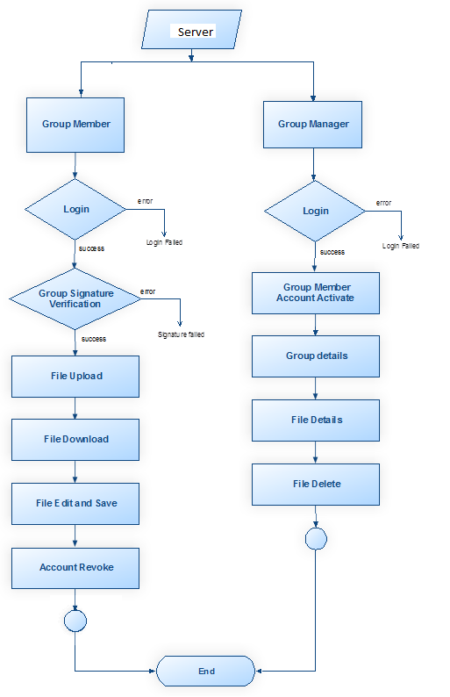

Fig6.1: Data Flow Diagram

11

**UseCase Diagram:**



Fig6.2: UseCase Diagram

**12**

**Sequence Diagram**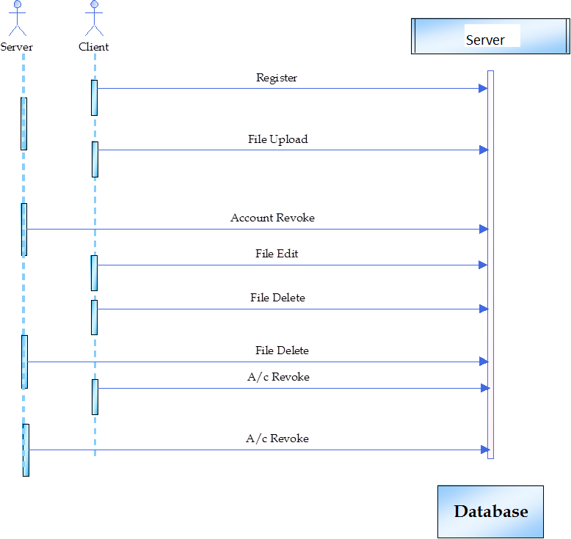

Fig6.3: Sequence Diagram

13

**CHAPTER 7**

**IMPLEMETATION**

**MODULES:**

1.Cloud Module

2.Group Manager Module

3.Group Member Module

4.File Security Module

5.Group Signature Module

6. User Revocation Module .

**MODULES DESCRIPTION:**

**1. Cloud Module :**

* In this module, we create a local Server and provide priced abundant storage services. The users can upload their data in the Server. We develop this module, where the cloud storage can be made secure. However, the cloud is not fully trusted by users since the SPs are very likely to be outside of the Server users’ trusted domain. Similar to we assume that the cloud server is honest but curious. That is, the cloud server will not maliciously delete or modify user data due to the protection of data auditing schemes, but will try to learn the content of the stored data and the identities of Server users.

14

**2.Group Manager Module :** Group manager takes charge of followings,

* Group manager takes charge of followings,

1. User registration,

2. User revocation, and

3. Revealing the real identity of a dispute data owner.

* Therefore, we assume that the group manager is fully trusted by the other parties. The Group manager is the admin. The group manager has the logs of each and every process in the cloud. The group manager is responsible for user registration and also user revocation.

**3.Group Member Module :**

* Group members are a set of registered users that will
* store their private data into the cloud server and
* Share them with others in the group.
* Note that, the group membership is dynamically changed, due to the staff resignation and new employee participation in the company. The group member has the ownership of changing the files in the group. Whoever in the group can view the files which are uploaded in their group and also modify it.

**4.File Security Module :**

* Encrypting the data file.
* File stored in the cloud can be deleted by either the group manager or the data owner.

15

**5.Group Signature Module :**

* A group signature scheme allows any member of the group to sign messages while keeping the identity secret from verifiers. Besides, the designated group manager can reveal the identity of the signature’s originator when a dispute occurs, which is denoted as traceability.
* Here, the signature is in the form of key. At the registration process the signature is sent to the user’s e-mail. This signature verification is mainly used to restrict the file access from unauthorized users. If the outside group member supposed to download the file of other group it will display the message of signature verification false.

**6. User Revocation Module :**

* User revocation is performed by the group manager via a public available revocation list (RL), based on which group members can encrypt their data files and ensure the confidentiality against the revoked users.
* If any misbehaviour of the group member, then group manager revoke

Or deactivate the group member. Group member can also revoke themselves.

Fig 7.1: SYSTEM ARCHITECTURE:

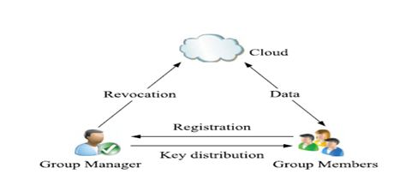

16

**CHAPTER 8**

**OUTPUT SCREENSHOTS:**

Fig8.1: Welcome Page

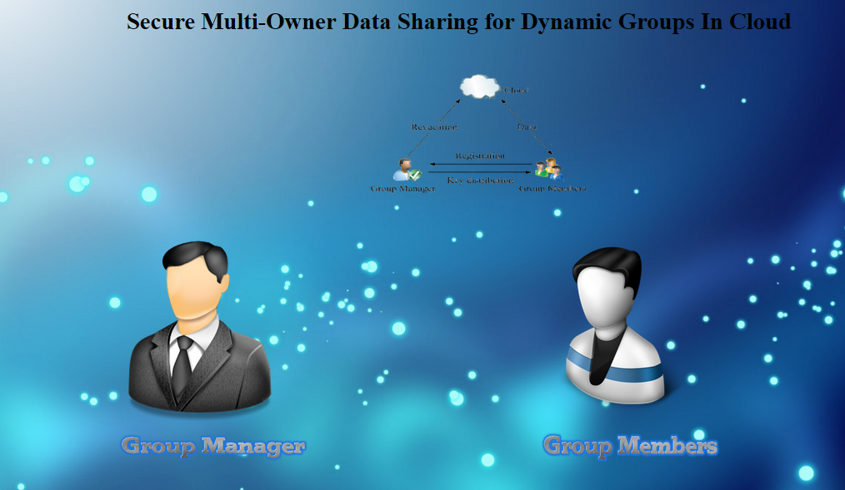

Fig 8.2: Admin Home Page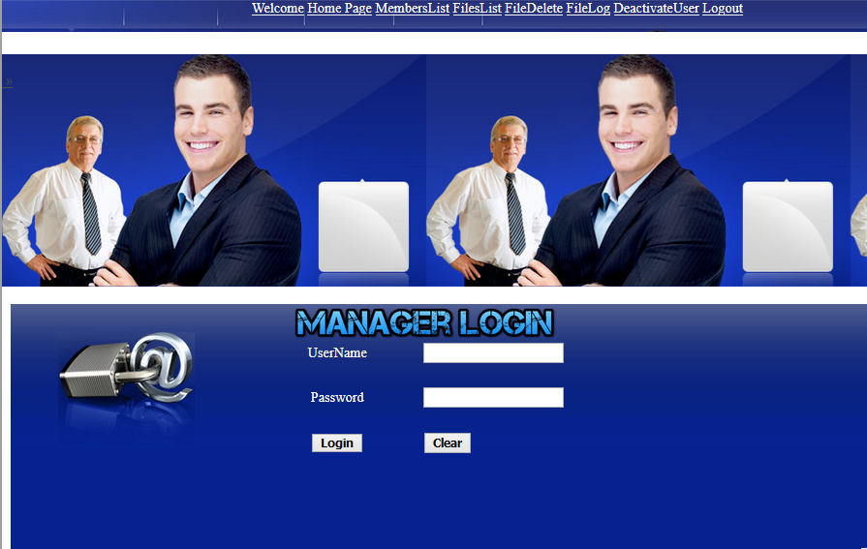

17

**Fig 8.3: Members List**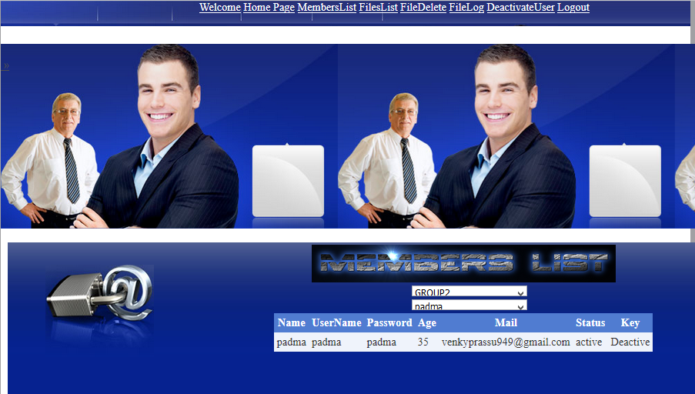

**Fig 8.4: File List**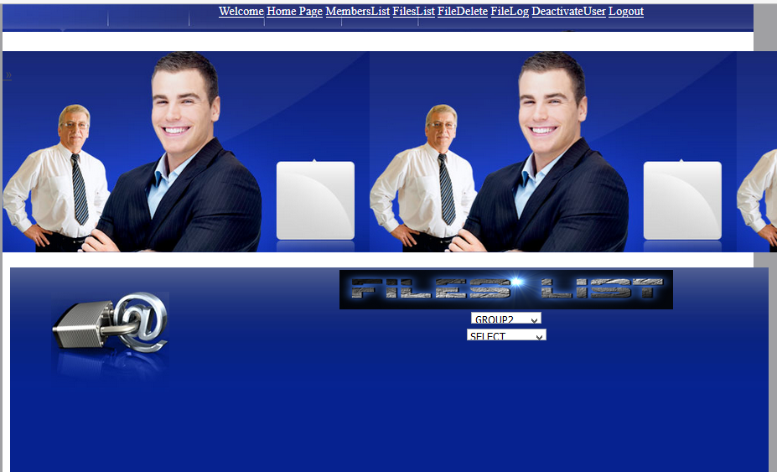

**18**

**Fig8.5: Deactivation Of User By Group Manager**

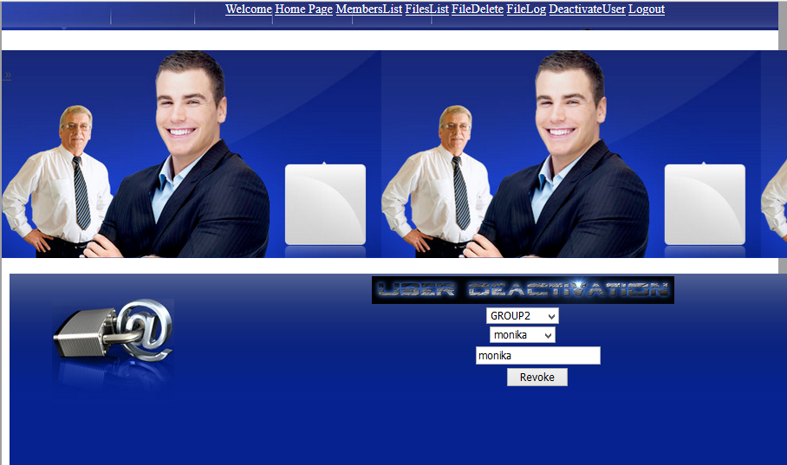

**Fig8.6 :User Registration**

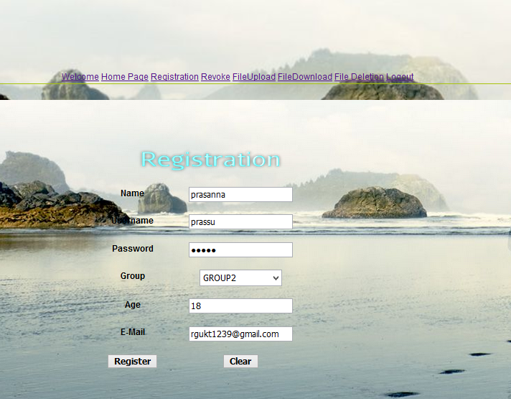

**19**

**Fig8.7: User Login**

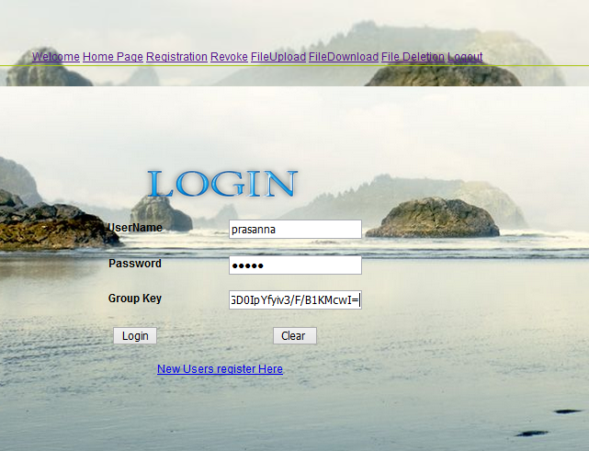

**Fig 8.8: Deactivation of User**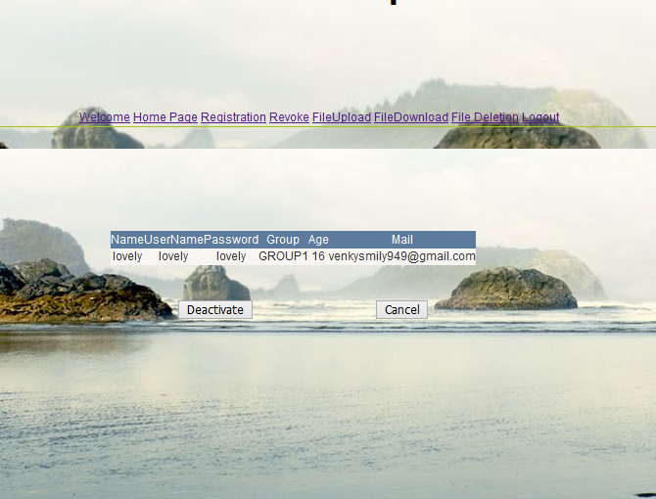

**20**

**Fig 8.9: File Upload**

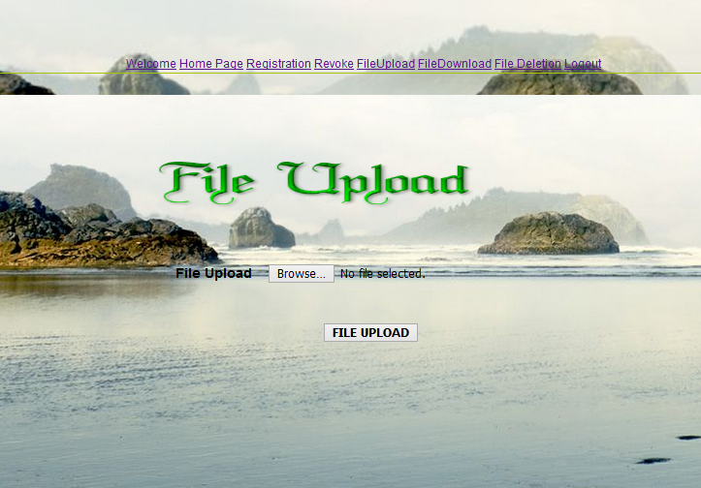

**Fig 8.10:File Download**

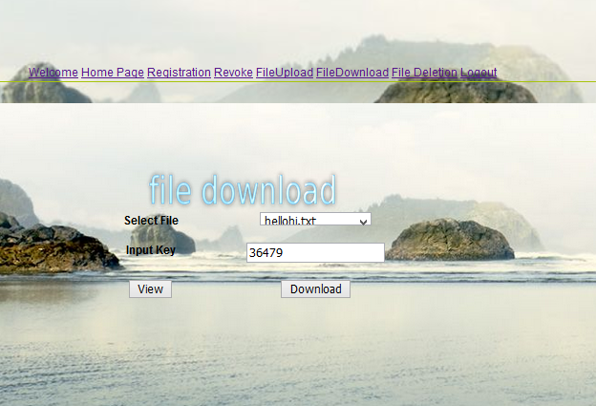

**21**

**Fig 8.11: File Deletion**

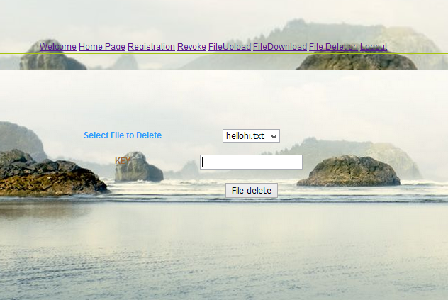

**22**

**CHAPTER 9**

**CONCLUSION:**

In this paper, we design a secure data sharing scheme, for dynamic groups called Mona Secure Multi-Owner Data Sharing for Dynamic Groups in the Cloud. In this, user is able to share data with others in the group without revealing identity privacy to the cloud. Additionally, It supports efficient user revocation and new user joining. More specially, efficient user revocation can be achieved through a public revocation list without updating the private keys of the remaining users, and new users can directly decrypt files stored in the cloud before their participation. Moreover, the storage overhead and the encryption computation cost are constant. Extensive analyses show that our proposed scheme satisfies the desired security requirements and guarantees efficiency as well.

23

**CHAPTER 10**

**Future Enhancement:**

Our project has been developed in a very short period of time and all the efforts have been taken so that this project is very efficient in its execution. Although, there still exists scope for the improvement of our project in the future.

Our project has been developed mainly by taking the example of the environment of the company. We can extend our project to the fields such as education, entertainment, various social networks and other wider areas. For example, we can employ our project in the universities to maintain the data base of the students which can be used by the groups of lecturers. Here lecturer becomes the group member and the head of the department becomes the group manager.

Further enhancement in the security of the data uploaded by the members can be done. We can also concentrate on creating sub groups in the groups.

We can concentrate on preserving identity privacy for its enhancement. Interaction between the group manager and the group member should be improved.

24

**References:**

[1] M. Kallahalla, E. Riedel, R. Swaminathan, Q. Wang, and K. Fu, “Plutus: Scalable Secure File Sharing on Untrusted Storage,” Proc. USENIX Conf. File and Storage Technologies, pp. 29-42, 2003.

[2] E. Goh, H. Shacham, N. Modadugu, and D. Boneh, “Sirius: Securing Remote Untrusted Storage,” Proc. Network and Distributed Systems Security Symp. (NDSS), pp. 131-145, 2003.

[3] R. Lu, X. Lin, X. Liang, and X. Shen, “Secure Provenance: The Essential of Bread and Butter of Data Forensics in Cloud Computing,” Proc. ACM Symp. Information, Computer and Comm. Security, pp. 282-292, 2010

[4] V. Goyal, O. Pandey, A. Sahai, and B. Waters, “Attribute-Based Encryption for Fine-Grained Access Control of Encrypted Data,” Proc. ACM Conf. Computer and Comm. Security (CCS), pp. 89-98, 2006.

[5] B. Waters, “Ciphertext-Policy Attribute-Based Encryption: An Expressive, Efficient, and Provably Secure Realization,” Proc. Int’l Conf. Practice and Theory in Public Key Cryptography Conf. Public Key Cryptography, http://eprint.iacr.org/2008/290.pdf, 2008.

**25**